Subject: PRF192- PFC
Workshop 08

Objectives:
Managing text files

Problem 1(1 mark):
Implement the problem introduced in the demonstration 1 of the lecture

Problem 2(1 mark):
Implement the problem introduced in the demonstration 2 of the lecture

Problem 3(1 mark):
Implement the problem introduced in the demonstration 3 of the lecture

Problem 4(1 mark):
Implement the problem introduced in the demonstration 4 of the lecture

Problem 5(1 mark):
Implement the problem introduced in the demonstration 5 of the lecture

Problem 6(3 mark):

- Data representing a student include: name, address, mark.
- A list of students are stored in the file students.txt as below:

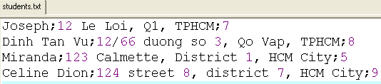

- Write a C-program that will print out the list of students in descending order based on their marks then the list will be written to the file students_2.txt with the same format as the previous file.

(Hint: Refer to the lecture’s slide when this problem is solved)

